**Title of work:** Introduction Lab – Food Truck

**Name:** Shani Patel

**Student number :**152243192

**Section Code:** NEE

**Date submitted:** 20/05/2021

**Professor's name:** Tevin Apenteng

Class Diagram

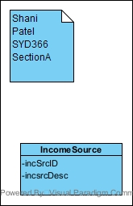

Systems Level Sequence Diagram

